
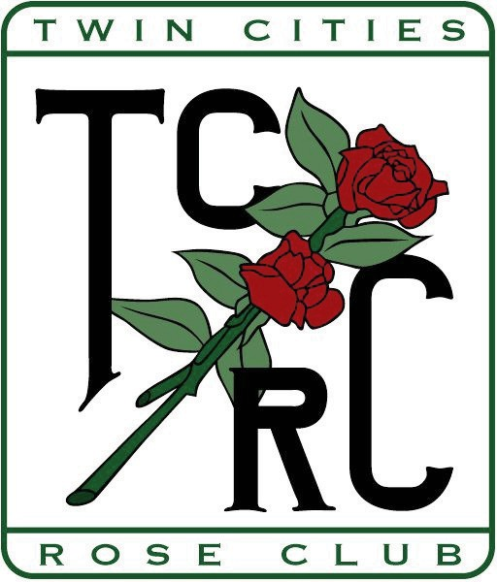
Twin Cities Rose Club

MEMBERSHIP FORM
January 1 to December 31, 2027

Name Add’l Member(s) (same household)
Street __City _____State __Zip ______
Phone ( ) __________ E-Mail ______________________
Cell Phone _________________ARS member______ Renewal New Member_______

What is/are your area(s) of interest? ( Check all that apply)
Gardening_______Photography _______Showing Arranging ___ Hybridizing _____Other ______

How many roses do you grow? H.T._______Floribundas Shrubs O.G.R ____ Minis _____

Membership Dues $15.00
Each Additional Member $2.50

_________ Total Enclosed

Please mail this form and your check payable to Twin Cities Rose Club to:
Andrew Gawboy
2900 Hilldale Ave NE, Minneapolis, MN 55418
For information call (507) 316-3161 or email dbechtle@gmail.com
Dues may also be paid through the Electronic Store.

