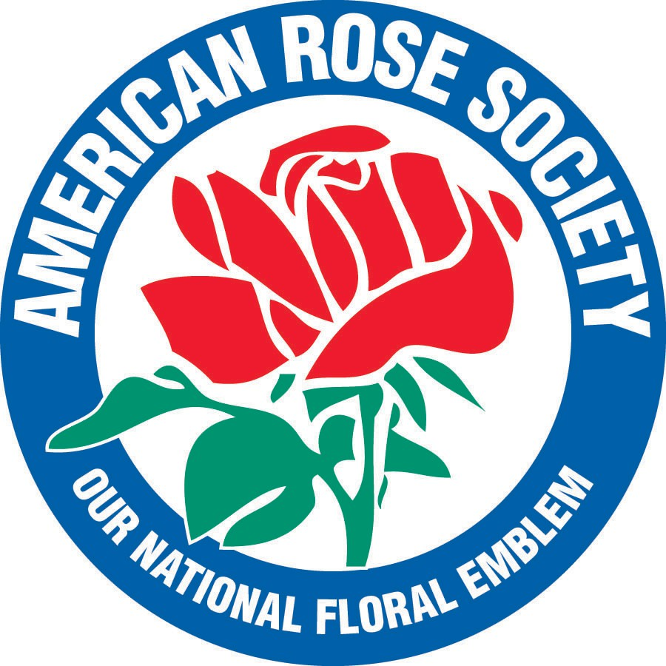
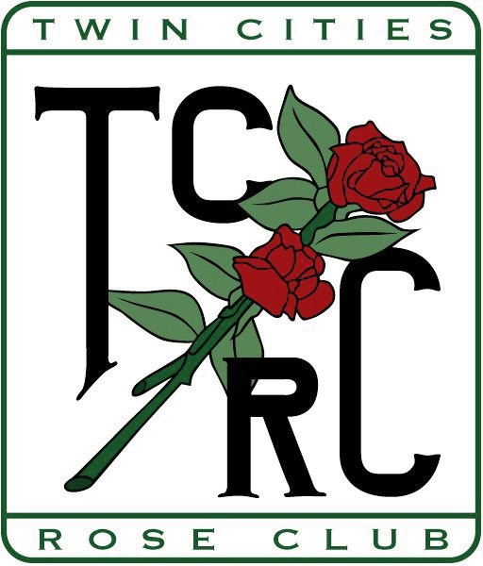

Twin Cities Rose Club

MEMBERSHIP FORM
January 1 to December 31, 2026

Name Add’l Member(s) (same household)
Street ___________________________________ City ____________ State __ Zip _____
Phone ( ) __________ E-Mail ____________
ARS Member_________ Renewal New Member_____

What is/are your area(s) of interest? ( Check all that apply) _______Gardening ________Photography _______Showing

Arranging ___ Hybridizing _____Other

How many roses do you grow? H.T. _______Floribundas Shrubs O.G.R ____ Minis

Membership Dues $15.00
Each Additional Member $2.50

Total Enclosed ____________

Please mail this form and your check payable to Twin Cities Rose Club to:
Andrew Gawboy
2900 Hilldale Ave NE, Minneapolis, MN 55418
For information call (507) 316-3161 or email dbechtle@gmail.com
Dues may also be paid through the Electronic Store.

