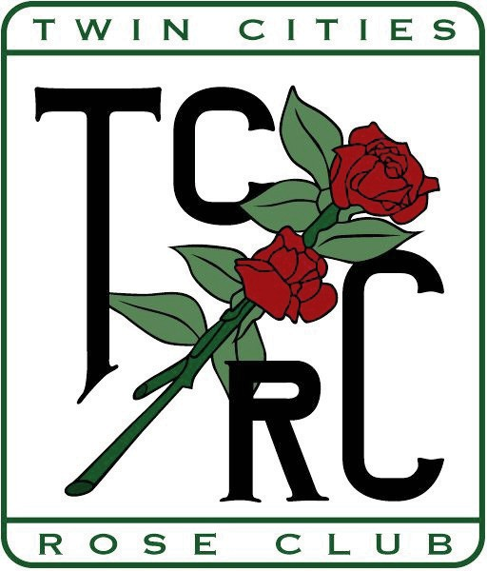

***Twin Cities Rose Club***

MEMBERSHIP FORM

January 1 to December 31, 2025

Name Add’l Member(s) (same household) Street City State Zip Phone ( ) E-Mail

ARS Member Renewal New Member

What is/are your area(s) of interest? Gardening Photography Showing

Arranging Hybridizing Other

How many roses do you grow? H.T. Shrubs O.G.R. Mini Membership Dues $15.00

Each Additional Member $2.50

Total Enclosed

Please mail this form and your check payable to Twin Cities Rose Club to:

**Andrew Gawboy**

**2900 Hilldale Ave NE, Minneapolis, MN 55418**

For information call (507) 316-3161 or email [dbechtle@gmail.com](mailto:dbechtle@gmail.com)